

**CS-114 - Fundamental of Programing**

**Lab Manual # 9**

**Lab Task**

Submitted To: Engr Muhammad Affan

Submitted By: Shahzaib Murtaza (466034)

Section: B

**1. Make 2D Array in C++ and print left diagonal and right diagonal sum of a 3x3 matrix.**

#include <bits/stdc++.h>

using namespace std;

int main(){

int a[3][3], sum1=0, sum2=0;

cout<<"Input Numbers:";

for(int i=0; i<3; i++){

for(int b=0; b<3; b++){

cin>>a[i][b];

}

}

cout<<"The values in the matrix are: \n";

for(int i=0; i<3; i++){

cout<<"| ";

for(int b=0; b<3; b++){

cout<<a[i][b]<<" ";

}

cout<<"|"<<endl;

}

int b=2;

for(int i=0; i<3; i++){

sum1+=a[i][i];

sum2+=a[b][i];

b--;

}

cout<<"Sum of left diagonal: "<<sum1<<endl

<<"Sum of right diagonal: "<<sum2<<endl;

return 0;

}

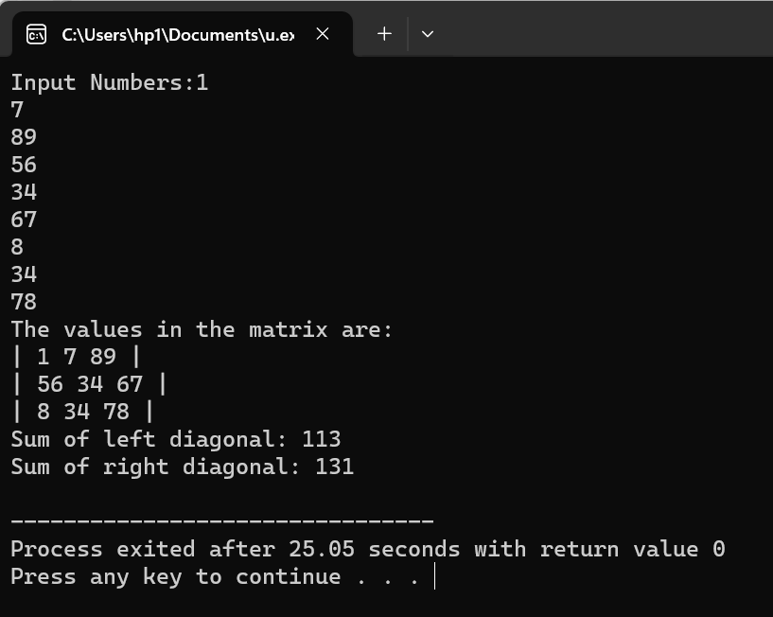

**2. Write a function to add two 2D arrays of size 3x3.**

#include <iostream>

using namespace std;

int main(){

int a[3][3], b[3][3], sum[3][3];

cout<<"Input Numbers:";

for(int c=0; c<3; c++){

for(int d=0; d<3; d++){

cin>>a[c][d];

}

}

cout<<"Input numbers in second matrix:";

for(int c=0; c<3; c++){

for(int d=0; d<3; d++){

cin>>b[c][d];

}

}

cout<<"The values in the matrix are:";

for(int c=0; c<3; c++){

cout<<"| ";

for(int d=0; d<3; d++){

cout<<a[c][d]<<" ";

}

cout<<"|\t| ";

for(int e=0; e<3; e++){

cout<<b[c][e]<<" ";

}

cout<<"|"<<endl;

}

for(int c=0; c<3; c++){

for(int d=0; d<3; d++){

sum[c][d]=a[c][d]+b[c][d];

}

}

cout<<"The sum of the two matrix is: \n";

for(int c=0; c<3; c++){

cout<<"| ";

for(int d=0; d<3;d++){

cout<<sum[c][d]<<" ";

}

cout<<"|"<<endl;

}

return 0;

}

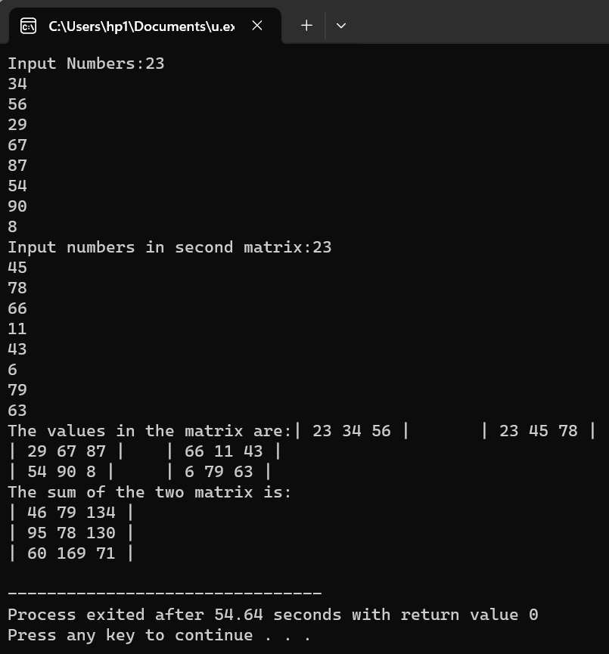

**3. Using 2D arrays in C++, take transpose of a 3x3 matrix. Make a transpose function.**

#include <iostream>

using namespace std;

int transpose(int a[3][3]){

int temp=0;

for(int b=0; b<3; b++){

for(int c=b+1; c<3; c++){

temp=a[b][c];

a[b][c]=a[c][b];

a[c][b]=temp;

}

}

}

int main(){

int a[3][3];

cout<<"Input Numbers:";

for(int b=0; b<3; b++){

for(int c=0; c<3; c++){

cin>>a[b][c];

}

}

cout<<"Numbers in matrix are: \n";

for(int b=0; b<3; b++){

cout<<"| ";

for(int c=0; c<3; c++){

cout<<a[b][c]<<" ";

}

cout<<"|"<<endl;

}

cout<<"Transpose of the matrix: \n";

transpose(a);

for(int b=0; b<3; b++){

cout<<"| ";

for(int c=0; c<3; c++){

cout<<a[b][c]<<" ";

}

cout<<"|"<<endl;

}

return 0;

}

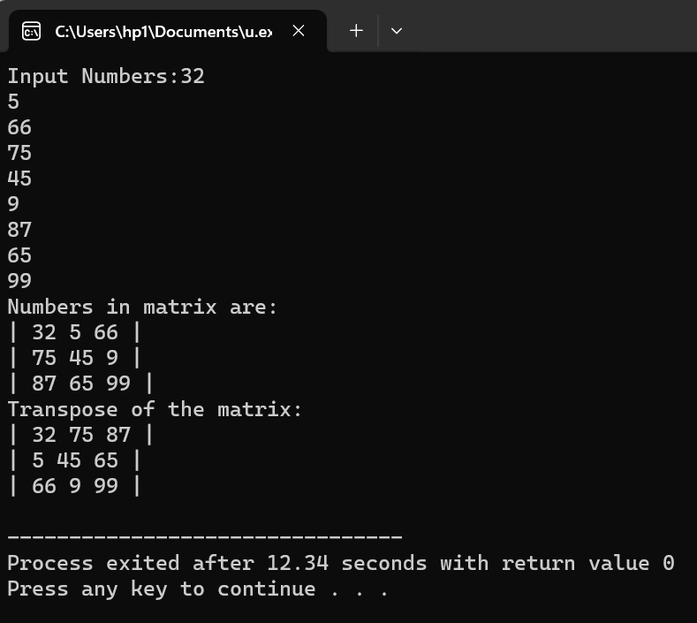

**4. Using 2D arrays in C++, implement 3x3 matrix multiplication. Make a function.**

#include <bits/stdc++.h>

using namespace std;

int multiply(int a[3][3], int b[3][3], int ans[3][3]){

for(int c=0; c<3; c++){

for(int d=0; d<3; d++){

for(int e=0; e<3; e++){

ans[c][d]+=a[c][e]*b[e][d];

}

}

}

}

int main(){

int a[3][3], b[3][3], ans[3][3]={{0},{0}};

cout<<"Input Numbers:";

for(int c=0; c<3; c++){

for(int d=0; d<3; d++){

cin>>a[c][d];

}

}

cout<<"Input Numbers:";

for(int c=0; c<3; c++){

for(int d=0; d<3; d++){

cin>>b[c][d];

}

}

cout<<"Numbers in matrix are:";

for(int c=0; c<3; c++){

cout<<"| ";

for(int d=0; d<3; d++){

cout<<a[c][d]<<" ";

}

cout<<"|\t| ";

for(int e=0; e<3; e++){

cout<<b[c][e]<<" ";

}

cout<<"|"<<endl;

}

multiply(a, b, ans);

cout<<"The product of the two matrix is: \n";

for(int c=0; c<3; c++){

cout<<"| ";

for(int d=0; d<3; d++){

cout<<ans[c][d]<<" ";

}

cout<<"|"<<endl;

}

return 0;

}

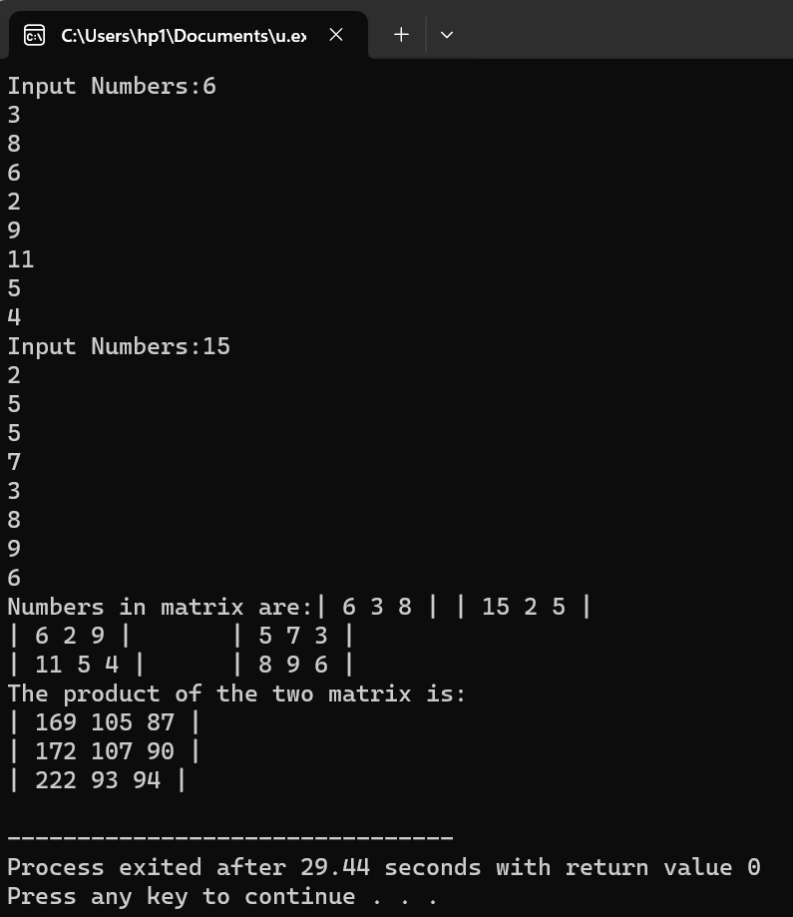

**5. Print the multiplication table of 15 using recursion.**

#include <iostream>

using namespace std;

int table(int n, int t=1){

if(t==11){

return 0;

}

cout<<t<<"*"<<n<<"="<<t*n<<endl;

return table(n, t+1);

}

int main(){

int n;

cout<<"Input an Integer: ";

cin>>n;

cout<<"The table of "<<n<<" is: \n";

table(n);

return 0;

}

